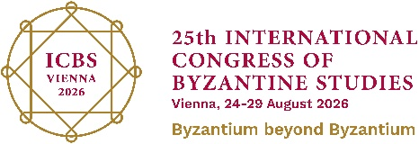
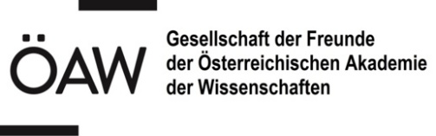

Dienstag, 25. August 2026, 19.30 Uhr
Institut für Musikwissenschaft,
Hof 9 (Campus AAKH),Garnisongasse 13

Program note

Dimitris Mousouras [Ένας μικρός Όρθρος] 2025 work for solo piano
[Small] Orthros (2025) by Dimitris Mousouras, dedicated to pianist Christos Marantos, bridges Western and Eastern traditions. Written for solo piano—a quintessential Western instrument—set in dialogue with a five-member choir, this work initiates an experimental exploration of Greek Byzantine music. By engaging directly with authentic original texts, the piece covers the most important parts (regarding the music/melos) of the Orthros the 1st part of the Christian mass in the East Orthodox Church.

Christos Marantos piano

Byzantine Choir Ensemble

Dimitrios Apostolakis, Georgios Demetriou, Dimitrios Arvanitis, Nikolaos Papadopoulos collaborating with Dimitris Mousouras

-----------------

I. Orthros in vathis… (intro) piano
II.a Kathisma prosomoion argo “kateplagi Iosif…”( Joseph was amazed…) - Byzantine Ensemble

IIb. Kathisma – piano

IIIa. Evlogitaria of Vatopedi Monastery - Byzantine Ensemble

IIIb. Evlogitarion -piano

IVa. Ainos (Laud) modus 3 and plagal 3rd

IVb. Ainos - piano

V.Doxologia (Doxology) modus plagal 4th (selection from Hourmouzios and Isaac Kosmas chant)

V.Doxologia -piano

Dimitris Mousouras (*1983). Greek composer, orchestrator, violinist and music teacher, based in Athens. His compositions include chamber, vocal and orchestral music. His music has been presented to date in Greece (Athens Music Hall, Nafplio, Volos, Rhodes and Kifissia Festivals, Deree the American gollege of Greece), in Austria (Musikverein, ORF Radiokulturhaus, Muth Saal, Brick-5), in Romania (Bucharest SIMN festival) from various ensembles such as the Ensemble Reconsil, Ensemble Kontrapunkte, Koehne String Quartet, the Webern Symphony Orchestra, etc. His composing interest expands from a wide range of styles and influences that derive from Greek and Byzantine tradition, several sciences, nature and (meta)physical phenomena. The living experiences [aka βίωμα] from all the aforementioned are the main poles of inspiration and composing process. Therefore the musical language is adopting according to each theme of inspiration and creation.

Christos Marantos is a pianist, performer, and artistic researcher who teaches at the J.S. Bach Musikschule and the mdw – University of Music and Performing Arts Vienna. A Bösendorfer Artist since 2021, he has performed on international stages, including the Musikverein, and at festivals such as Wien Modern. He is the founder of the "Santorini Masterclasses" and conducts workshops internationally, including at Conservatorio UNAL in Bogotá, Mahidol University in Bangkok and Tokyo College of Music TCM. As a researcher, Christos is a key member of the 'Trans-bodied knowledge' project at TU Wien (2023). His artistic doctorate at the mdw, 'Enacted_sounds>>notating affordances,' focuses on multisensorial scores connecting sound and space. His research has been exhibited at the Kunstmuseum Waldviertel and in the Austrian Pavilion at World Expo Osaka 2025. Driven by humanitarian concern, he curated the Filmfestival ViennAthens, focusing on migration and climate change under the auspices of UNESCO Austria

Byzantine Vocal Ensemble: The ensemble consists of cantors, chanting in the Orthodox Church of Holy Trinity in Vienna (members of the Choir of the Metropolis of Austria) and they perform specifically along with Dimitris Mousouras and Christos Marantos for this concert.

